**Health and Wellness Coaching**

**Major Project Report Submitted to**

**SRI PADMAVATI MAHILA VISVAVIDYALAYAM**

**In Partial fulfilment of the requirement for the**

**MASTER OF COMPUTER APPLICATIONS**

***IV SEMESTER***

**By**

**NAMAGUNDLA LAVANYA Roll No: 2022MCA16060**

**Under the guidance of**

**Dr. VENKATAKRISHNA**



Accredited by **NAAC with A+** Grade ISO 9001 : 2015 Certified

**DEPARTMENT OF COMPUTER SCIENCE**

**SRI PADMAVATI MAHILA VISVAVIDYALAYAM**

**(Women’s University)**

**Tirupati-517502(A.P), Andhra Pradesh**

**SEPTEMBER, 2024**

**DEPARTMENT OF COMPUTER SCIENCE**

**SRI PADMAVATI MAHILA VISVAVIDYALAYAM**

**(Women's University)**

**Tirupati-517502, Andhra Pradesh, India**



**CERTIFICATE**

This is to certify that the project work entitled “**Health and Wellness Coaching”** is a bonafide record of work carried out by **NAMAGUNDLA LAVANYA(ROLLNO:2022MCA16060)**

in the **Department of Computer Science**, **Sri Padmavati Mahila Visvavidyalayam**, Tirupati in partial fulfilment of the requirements of IV Semester of **MASTER OF COMPUTER APPLICATIONS**. The content of the Project Report has not been submitted to any other University/Institute for the award of any degree.

***Guide Head of the Department***

DECLARATION

We hereby declare that MCA III Semester Minor Project entitled **“Health and Wellness Coaching”** was done at the **Department of Computer Science**, **Sri Padmavati Mahila Visvavidyalayam**, Tirupati, in the year 2023-2024 under the guidance of Dr.Venkatakrishna in partial fulfilment of requirements of MCA IV Semester.

I also declare that this project is my original contribution of the best of my knowledge and belief. I further declare that this work has not been submitted for the award of any other degree of this or any other university/Institution.

Signature of the Student

1.

ACKNOWLEDGEMENT

We am greatly indebted to our guide **Dr.Venkatakrishna** for taking keen interest on my project work and providing valuable suggestions in all the possible areas of improvement.

I/We express my sincere thanks to the teaching staff of the Department of Computer Science for extending support and encouragement to me in all the stages of the project work.

I/Wegratefully acknowledge and express my gratitude to the non-teaching staff of the Computer Science Department who supported us in preparing the project report.

Signature of the Student

INDEX

SL.No. Content Page No.

**ABSTRACT**

1. **INTRODUCTION**
   1. Organization profile (if project done at outside organization)
   2. University profile
2. **PROBLEM DEFINITION**
   1. Aim
   2. Problem Definition
      1. Existing System
      2. Proposed System
   3. Objectives
3. **SYSTEM ANALYSIS**
   1. Software Requirement Specifications
   2. System Requirement
      1. Hardware Requirements
      2. Software Requirements

3.3. Feasibility Study

3.3.1. Operational Feasibility

3.3.2. Technical Feasibility

3.3.3. Economical Feasibility

3.4. Modelling Approaches

**(Based on the selected project)**

3.4.1. UML diagrams

3.4.1.1. Use Case Diagrams

3.4.1.2. State Diagrams

3.4.1.3. Sequence Diagrams

3.4.2. Data flow Diagrams

3.4.4.1. ER-Diagrams

SL. No. Content Page No.

**4. SYSTEM DESIGN**

4.1. Design principle

4.2. Database Design

4.2.1. Normalization

4.2.2. Database Tables

4.3. Modularization

4.3.1. Hierarchical chart

4.3.2. Module Description

**5. SYSTEM TESTING**

5.1. Testing Schemes

5.1.1.

5.1.2. (such as Unit Testing, WBT, BBT,IT, Validation Testing .. etc.. as per the usage in the project)

5.2. Test cases

**6. IMPLEMENTATION**

**7. CONCLUSION**

7.1. Performance of Proposed System

7.2. Limitation

7.3. Future Enhancements

**BIBILOGRAPHY**

**APPENDICES**

APPENDIX A: Screens

* Screen Shots
* Reports

APPENDIX B: User Manual

APPENDIX C: Source code

ABSTRACT

An Artistblog permits a customer to submit online orders for arts and services from a store that serves online customers. This will present an online display of an order cut off time and associated delivery window for arts selected by the customer. The system accepts the customer’s submissions of a purchase order for the item in response to a time of submission being before the order cut off time. The Artistblog does not settle with a supplier of the customer until the item selected by the customer is picked from inventory but before it is delivered. Therefore, the customer can go online and make changes to the order. In addition, available service windows are presented to the customer as a function of customer selected order and service types and further, the order picking is assigned in accordance with a picker’s preference. When ordering goods, many websites provide a virtual shopping cart for holding items selected for purchase. Successive items selected for purchase are placed into the virtual shopping cart until a customer completes their shopping trip. Virtual shopping carts may be examined at any time, and their contents can be edited or deleted ar the options of the customer

The following are the modules in this system

1.Admin

2.Customer

3.Product

4. Transactions

5. Stock

6. Orders &Delivery

INTRODUCTION

At Health and Wellness Coaching, where we specialize in providing expert health services to individuals. With years of experience and a dedicated team

of consultants, we streamline the training process, making it easier for you to achieve your global aspirations.

Health and Wellness Coaching mission is to empower the clients to navigate the life with confidence. Whether you're suffering from over weight, obesity, or any other health problems, we’ll help you to recover.

What health and wellness coaching Offer **:**

• Comprehensive Consultation**:** Experienced consultants provide personalized

guidance tailored to your unique circumstances and requirements.

• Efficient training**:** Streamlines the training process, from assessing

eligibility to handling your problems.

• Transparent Solutions: We believe in transparency and integrity. Services are

transparent, and our fees are competitive, with no hidden costs.

Why to Choose Health and Wellness Coaching

• Expertise**:** Benefit from the years of experience and in-depth knowledge of

Health and Nutrition.

• Customer Satisfaction**:** We prioritize customer satisfaction and go the extra

mile to exceed your expectations.

• Tailored Solutions**:** Every client is unique, and we tailor our services to meet

your specific needs and objectives.

1.2 UNIVERSITY PROFILE

Sri Padmavati Mahila Visvavidyalayam (university for women) was founded in the year 1983 by N.T. Rama Rao, the Chief Minister of Andhra Pradesh, with the fervent desire to train women students as better builders of nation and to include skills of leadership in all aspects of life. The University was established under the Sri Padmavati Mahila Visvavidyalayam Act of 1983, which has come in to force on 14th of April 1983, it was started with ten faculties and 300 students and 20 staff members. In pursuance of objectives of university is awarded “A+ Grade” by NAAC.

The campus of Sri Padmavati Mahila Visvavidyalayam is spread out in lush green area of 138.43 acres. The university is situated as a distance of 3 kilometres from railway and bus stations of Tirupati. The campus has the necessary buildings to run its academic programs and administrative machinery. There are separate Buildings for humanities and science, university’s Administration, Central Library, University Auditorium, Sericulture complex and school of Pharmaceutical Sciences and also an independent building for Computer Science, Computer Centre and examination hall.

PROBLEM DEFINITION

2.1Aim:

Health and Wellness Coaching serves as your indispensable ally in achieving your global mobility goals. Whether you're an individual seeking to explore new horizons in your life. ThroughHealth and Wellness Coaching, you can:

• Navigate good health habits**:** Health and Wellness Coaching will provide you the good health plans without wasting your time

• Ensure Compliance**:** Stay updated with the latest health coaching centres and ensure compliance with minimizing the risk of complications or delays.

• Expand Opportunities**:** Unlock a world of opportunities for your health and enabling you to pursue your aspirations with confidence.

• Receive Personalized Guidance:Benefit from tailored consultation services

that address your unique circumstances and objectives, providing clarity and

peace of mind throughout thecoaching journey.

• Achieve Peace of Mind**:** With Health and Wellness Coaching by your side, you can navigate the complexities in health , knowing that you have a trusted partner dedicated to your success.

2.2 Problem Definition

2.2.1 Existing System**:**

Navigating the complexities of health and wellness presents numerous challenges for individuals. Existing approaches to address these challengesoften involve extensive research, understanding ofhealth regulations, and navigating bureaucratic processes, which can be time-consuming and overwhelming. Many individuals and businesses struggle to

decipher the intricate health requirements, leading to delays, rejections, or even legal complications. Existing methods to solve this problem is given below.

Traditional methods of addressing health-related challenges often involve relying on personal research, seeking guidance from government websites

or embassies, or engaging the services of legal professionals. While these

approaches may provide some assistance, they often lack the personalized guidance and comprehensive support necessary to navigate the health and wellness coaching efficiently and effectively. Additionally, the cost associated with legal consultations or the risk of misinformation from unofficial sources can further exacerbate the problem.

2.2.2 Proposed System:

At Health and Wellness Coaching, we propose a comprehensive solution to address the existing challenges in the training process. Our method revolves around leveraging our expertise, experience, and personalized approach to provide training services.

• Efficient Processing:Streamlines procedures, from eligibility assessment to

documentation, minimizing delays and maximizing success rates for hassle

free coaching applications.

• Transparency**:** Ensures clear communication, keeping you informed about

requirements and regulations every step of the way, promoting confidence and trust in the process.

• Cost-Effectiveness: Health and Wellness Coaching is designed to offer value for money, providing quality consultation without breaking the bank, making

your training affordable and accessible.

SYSTEM ANALYSIS

3.1 Software Requirement Specifications:

Software Requirement Specifications (SRS) for a Health and Wellness Coaching website outline the functional and non-functional requirements necessary for the development of the website. Below are some key components typically included in an SRS for an ArtistBlogwebsite:

1.Functional Requirements

2.Non-Functional Requirements

3.User Interface Requirements

4.System Architecture

3.2 System Requirement**s**

3.2.1 Hardware Requirements:

• Computer System**:** A desktop or laptop with sufficient processing power and

memory to handle web development tasks efficiently.

• Internet Connection:Reliable internet connectivity for accessing online

resources, documentation, and testing website responsiveness.

3.2.2 Software Requirements:

• Operating System:Windows, macOS, or Linux compatible with HTML,

CSS, XAMPP server, and WordPress.

• XAMPP Server: Apache**,** MySQL, PHP, and Perl (or equivalent) for

hosting the WordPress website locally during development and testing.

• WordPress: Content management system (CMS) for managing website

content, themes, and plugins.

• Web Browser**:** Latest versions of popular web browsers such as Google

Chrome, Mozilla Firefox, or Safari for testing website compatibility and

responsiveness**.**

• Text Editor:Software for writing and editing code (e.g., Sublime Text,

Visual Studio Code) for HTML, CSS, and WordPress theme customization

3.3 Feasibility study

The feasibility of the project is analysed in it is phase and business proposal in put forth with a very general plan for the project and some cost estimates. Suring system analysis the feasibility study of the proposed system is t be carried out. This is to ensure that the proposal system is not a burden to the company. For feasibility analysis, some understanding of the major requirements for the system is essential.

Three key conditions involved in the feasibility analysis are:

3.3.1 Economic Feasibility

This study is carried out to check the economic impact that the system will have on the organisation. The amount of fund that the company can post into the research and development of the system is limited. The expenditure must be justified. Thus the developed system as well within the budget and this was achieved because most of the technologies used are freely available. Only the customised products can be purchased.

3.3.2 Technical Feasibility

This study is carried out to check the technical feasibility, that is, the technical requirements of the system. Any system developed must not have a high demands on the available technical resources. This will lead to high demands on the available technical resources. This will lead to high demands being placed on the client. The developed system must have a modest supplement, as only minimal or null changes are required for implementing the system.

3.3.3 Operational Feasibility

The aspect of study is to check the level of acceptance of the customer. This includes the process of training the user to use the system efficiently. The user must not be understand the system, instead must accept is a s necessity. The level of acceptance be the user society depends on the methods the are employed to educate the user about the system and to make.

3.4 Modelling Approaches

3.4.1 UML Diagrams

UML stands for Unified Modelling Language. UML is a standardized general-purpose modelling language in the field of object-oriented software engineering. The standard is managed, and was created by, the Object Management Group.

The goal is for UML to become a common language for creating models of object oriented computer software. In its current form UML is comprised of two major components: a Meta-model and notation. In the future, some form of method or process may also be added to: or associated with, UML.

The Unified Language is a standard language for specifying, Visualization, Constructing and documenting the artifacts of software system, as well as for business modelling and other non-software system.

The UML represents a collection of best engineering practices that have proven successful in the modelling of large and complex system.

The UML is a very important part of developing objects oriented software and the software developed process. The UML uses mostly graphical notations to express the design of software project.

3.4.1.1 Use Case Diagram:

A use Case defines a goal-oriented set of interactions between external actors and the system under consideration. Since sometimes we will not be able to specify completely the behaviour of the system by just state diagrams by just State Diagrams, hence we use use-cases.

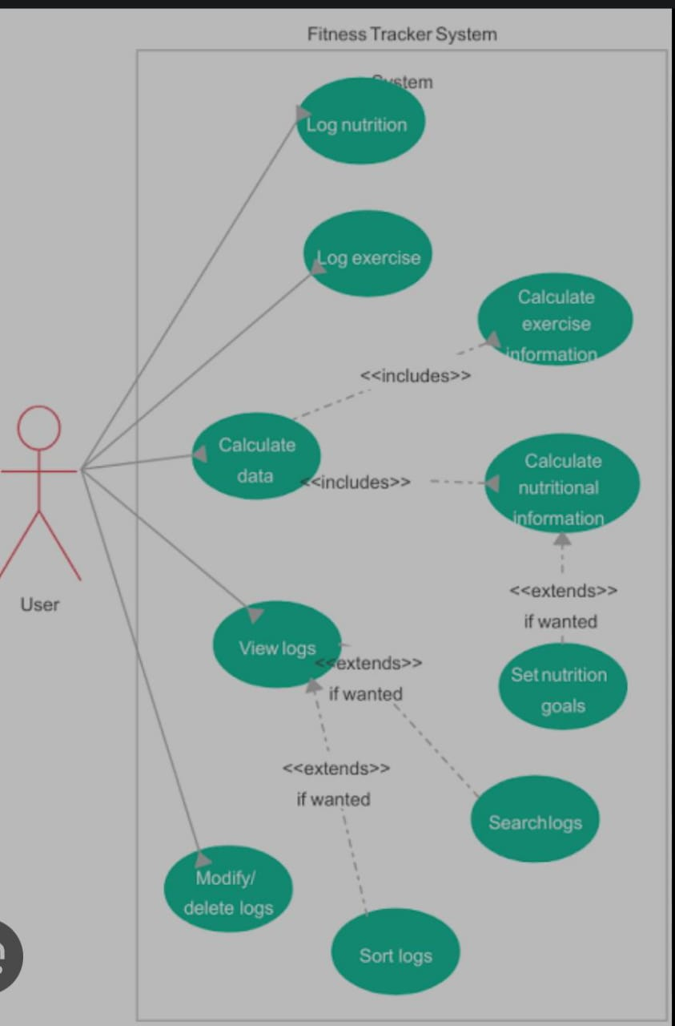

3.4.1.2 State chart Diagram:

State chart diagram is one of the five UML diagrams used to model the dynamic nature of a system. They define different states of an object during its lifetime and these states are changed by events. State chart diagrams are useful to model the reactive systems. Reactive systems can be defined as a system that responds to external or internal events.

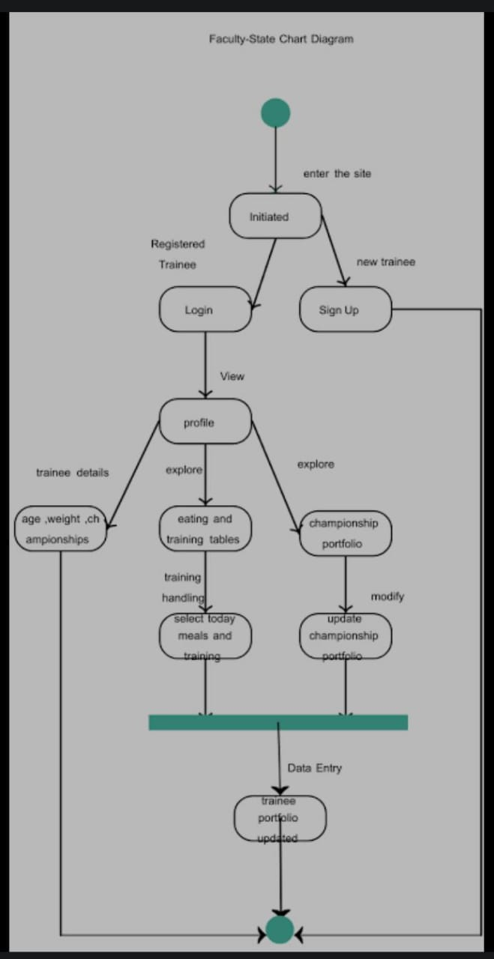

3.4.2 Data Flow Diagram:

A data flow diagram (DFD) maps out the flow of information for any process or system. It uses defined symbols like rectangles, circles and arrows, plus short text labels, to show data inputs, outputs, storage points and the routes between each destination. Data flowcharts can range from simple, even hand-drawn process overviews, to in-depth, multi-level DFDs that dig progressively deeper into how the data is handled.

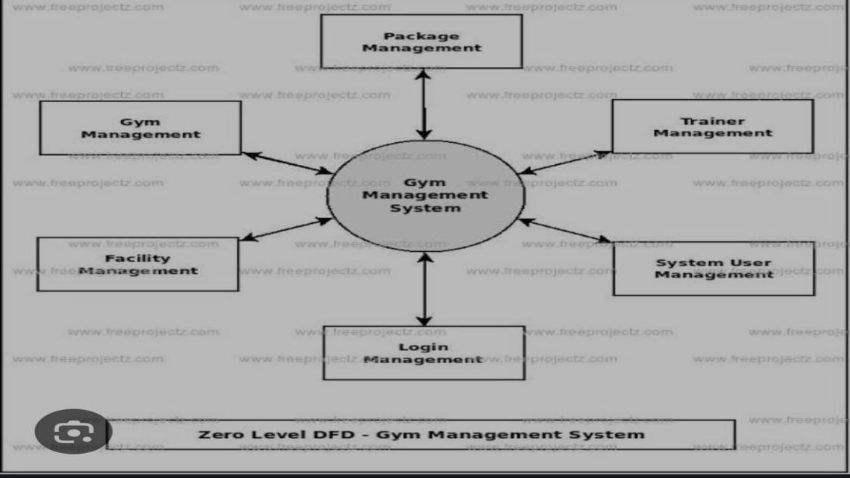

3.4.3 Data Models:

3.4.3.1 ER Diagram:

An entity-relationship model describes interrelated things of interests in a specific domain of knowledge. A basic ER model is composed of entity types and specifies relationships that can exist between entities(instances of those entity types).

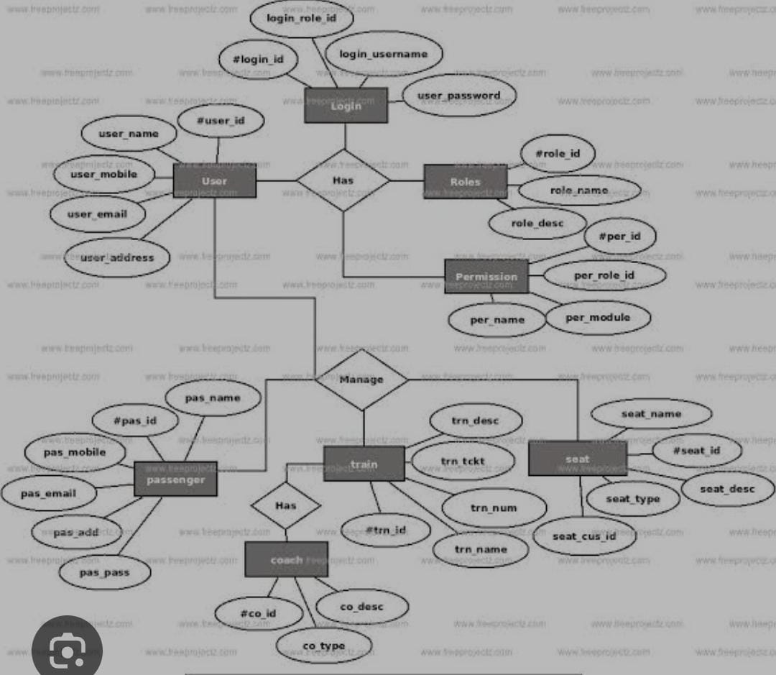

4. SYSTEM DESZIGN

4.1 Design principle:

* Basic design principles that enable the software engineer to navigate the design process

* The design should be tracked to the analysis model

* The design should minimize the intellectual distance between the software and the problem on exists in the real world

* The design should exhibit uniformly and integrity

* The design should be structure to accumulate changes

* The design is not coding and the coding is not design

* The design should be accessed for the quality

8 Golden Rules For System Design

* Strive for consistency
* Enable shortcuts for frequent users
* Design dialogues to yield closer
* Offer simple error handling
* Permit easy reversal of actions
* Support internal focus of control
* Reduce short term memory found on user

4.2 DATABASE DESIGN:

Normalization:

Normalization is the process of efficient organizing data in a database. There are the two poalsof the normalization process: Eliminating redundant data and ensuring data dependencies make sense. Both id these goals as they reduce the amount of space n database consumes and ensure that data us logically sored. There are several benefits for using normalization in database.

Benefits: Eliminates data redundancy

Improve performance

Faster update due to less number of columns in one table

There are the different types of normalization.

1.First Normal Form(1NF):

First normal form sets very basic rule for an organized database.

Eliminate duplicate columns from the table.

Create duplicate tables for each group of related data and identify each row with unique column or set of columns (the primary key) create primary key.

2. Second normal form (2NF):

The rule of second normal form on a database can be described as

1. Fulfil the requirements of the first normal form
2. Each non-key attribute must be functionally dependent on the primary key

3.Third normal form (3NF):

Third normal form is the final stage of the most common normalization process. The rule for this is

1. Fulfil the requirements if second normal form.
2. Has no transitive functional dependency.

4.3. Modularization

Modularization involves breaking down the project into smaller, manageable modules or components, each responsible for specific functionality or feature. For a wedding planner website, modularization can enhance maintainability, scalability, and collaboration among developers. Here's how you can modularize the website:

4.3.1Module Description:

1.User Authentication Module:

a. Responsible for handling user registration, login, and authentication processes.

b. Includes pages for user registration, login, password.

2. Dashboard Module:

a. Provides personalized dashboards for users after login.

b. Includes modules for managing events, booking, managing events

3.Booking Module:

a. Enable users to book services from vendors for their events.

b. Including features for browsing available services, making booking, and managing

bookings.

4.Messaging Module:

a. Facilitates between users, vendors, and planners.

b. Includes features for sending and receiving messages, managing conversations.

5. SYSTEM TESTING

5.1Testing schemes:

The purpose of testing is to discover errors. Testing is the process of trying to discover every conceivable fault or weakness in a work product. It provides a way to check the functionality of components, sub assemblies, assemblies and/or a finished product It is the process of exercising software with the intent of ensuring that the Software system meets its requirements and user expectations and does not fail in an unacceptable manner. There are various types of test. Each test type addresses a specific testing requirement.

5.1.1.

Unit testing:

Unit testing involves the design of test cases that validate that the internal program logic is functioning properly, and that program inputs produce valid outputs. All decision branches and internal code flow should be validated. It is the testing of individual software units of the application .it is done after the completion of an individual unit before integration. This is a structural testing, that relies on knowledge of its construction and is invasive. Unit tests perform basic tests at component level and test a specific business process, application, and/or system configuration. Unit tests ensure that each unique path of a business process performs accurately to the documented specifications and contains clearly defined inputs and expected results.

Integration testing:

Integration tests are designed to test integrated software components to determine if they actually run as one program. Testing is event driven and is more concerned with the basic outcome of screens or fields. Integration tests demonstrate that although the components were individually satisfaction, as shown by successfully unit testing, the combination of components is correct and consistent. Integration testing is specifically aimed at exposing the problems that arise from the combination of components.

Functional Testing:

Functional tests provide systematic demonstrations that functions tested are available as specified by the business and technical requirements, system documentation, and user manuals. Functional testing is centered on the following items:

Valid Input : identified classes of valid input must be accepted.

Invalid Input : identified classes of invalid input must be rejected.

Functions : identified functions must be exercised.

Output : identified classes of application outputs must be exercised.

Systems/Procedures : interfacing systems or procedures must be invoked.

Organization and preparation of functional tests is focused on requirements, key functions, or special test cases. In addition, systematic coverage pertaining to identify Business process flows; data fields, predefined processes, and successive processes must be considered for testing. Before functional testing is complete, additional tests are identified and the effective value of current tests is determine

5.1.2

System Test

System testing ensures that the entire integrated software system meets requirements. It tests a configuration to ensure known and predictable results. An example of system testing is the configuration-oriented system integration test. System testing is based on process descriptions and flows, emphasizing pre-driven process links and integration points.

Black Box Testing

Black Box Testing is testing the software without any knowledge of the inner workings, structure or language of the module being tested. Black box tests, as most other kinds of tests, must be written from a definitive source document, such as specification or requirements document, such as specification or requirements document. It is a testing in which the software under test is treated, as a black box .you cannot “see” into it. The test provides inputs and responds to outputs without considering how the software works

White Box Testing

White Box Testing is a testing in which in which the software tester has knowledge of the inner workings, structure and language of the software, or at least its purpose. It is purpose. It is used to test areas that cannot be reached from a black box level

5.2 Test Cases:

Unit Testing

Unit testing is usually conducted as part of a combined code and unit test phase of the software lifecycle, although it is not uncommon for coding and unit testing to be conducted as two distinct phases.

Test Strategy and approach:

Field testing will be performed manually and functional tests will be written in detail

Test Objectives:

• All field entries must work properly.

• Pages must be activated from the identified link.

• The entry screen, messages and responses must not be delayed.

Features To be tested:

• Verify that the entries are of the correct format.

• No duplicate entries should be allowed.

• All links should take the user to the correct page.

Integration Testing:

Software integration testing is the incremental integration testing of two or more integrated software components on a single platform to produce failures caused by interface defects. The task of the integration test is to check that components or software applications, e.g. components in a software system or – one step up – software applications at the company level – interact without error.

Test Results**:** All the test cases mentioned above passed successfully. No defects encountered. AcceptanceTesting:

User Acceptance Testing is a critical phase of any project and requires significant participation by the end user. It also ensures that the system meets the functional requirements.

Test Results: All the test cases mentioned above passed successfully. No defects encountered.

6. IMPLEMENTATION

Implementation literary means implementation phase if the software deals with the translation of the design specification into put into effect or to carry out. The system the source code. The ultimate goal of the implementation is t write the source code amenal documentation so that it can be verified easily. The code documentation should be written in manner that cases debugging, testing and modification system flowchart, Sample output, etc., is part of the implementation.

An effort was made to satisfy the following goals in order.

* Clarity and simplicity of the code.
* Minimization of hard coding.

7. CONCLUSION

7.1 Performance of the Proposed System

The performance of the proposed system for ArtistBlog is expected to be robust and efficient, providing users with a seamless and responsive experience. Here's how the system's performance can be evaluated:

Page Load Speed: Aim for fast page load times to ensure a smooth browsing experience for users. Implement optimization techniques such as image compression, browser caching, and content delivery network (CDN) integration to minimize load times.

Scalability: Design the system to handle increasing traffic and content without sacrificing performance. Utilize scalable hosting solutions, efficient database design, and caching mechanisms to accommodate growth and spikes in user activity.

Server Response Time: Monitor server response times to ensure timely delivery of content to users. Optimize server configurations, database queries, and application code to minimize response times and improve overall system responsiveness.

Concurrency Handling: Evaluate the system's ability to handle multiple concurrent user interactions, such as posting comments, accessing content, and performing searches, without experiencing slowdowns or errors.

7.2 Limitations:

Content Quality Control: Without a robust moderation system, there's a risk of low-quality or inappropriate content being posted, potentially tarnishing the blog's reputation.

Limited Interactivity: While users can comment on posts, the platform may lack more advanced interactive features such as live chats, forums, or collaborative projects.

Dependency on User-Generated Content: The success of the blog relies heavily on artists and users contributing content. If there's a lack of engagement or participation, the blog may struggle to maintain relevance.

Resource Intensive: Hosting multimedia content like high-resolution images, videos, and audio files can consume a significant amount of bandwidth and storage space, potentially leading to high hosting costs.

7.3 Future Enhancements:

Community Features: Introduce features like forums, messaging systems, and user profiles to foster a stronger sense of community among artists and users.

Collaborative Projects: Enable users to collaborate on art projects, exhibitions, or workshops directly through the platform, fostering collaboration and networking among artists.

Advanced Search and Filtering: Enhance search functionality with advanced filtering options based on criteria like art medium, genre, artist location, and popularity.

Personalization: Implement personalized content recommendations based on user preferences, viewing history, and interactions to enhance user engagement and satisfaction.

Live Events and Workshops: Introduce features for hosting and promoting live events, workshops, and webinars, providing additional value to users and attracting a wider audience.

APPENDIX



